ELECTROIMPACT, INC.
Corporate Headquarters
4413 CHENNAULT BEACH ROAD
MUKILTEO WA 98275
PH: (425) 348-8090 FAX (425) 348-0716
Visit Us ON the Web: www.electroimpact.com

FLEXRIVETER / C-Frame Riveter Series

FLEXRIVETER

Electroimpact, Inc. is pleased to offer the all electric FlexRiveter C-Frame Drill Rivet Machine. The Drill Rivet Machine can be supplied with various options to meet your manufacturing needs. Ease of set-up and tool-changes with minimum downtime and maintenance.

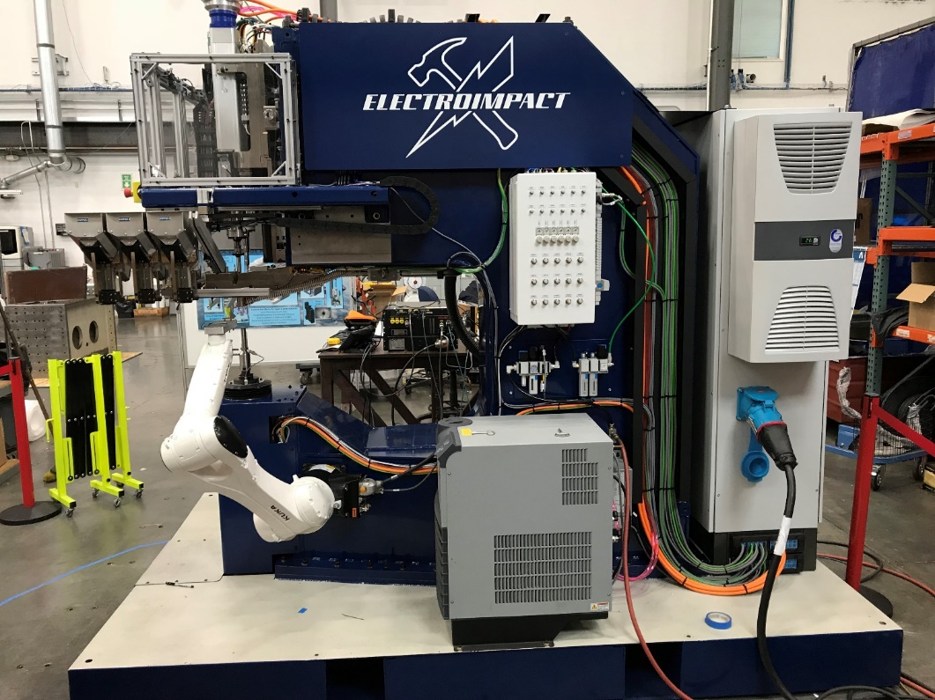

FLEXRIVETER WITH TIPPING NOSE
In vertical axis riveting the workpiece is in the HORIZONTAL PLANE and the tools work perpendicular to the workpiece or vertical axis.

Drill Spindle
- During the normal drill cycle the hole is produced in the part. Using Drill spindle is Fischer SD60124 with pneumatic drawbar for HSK40.
- Spindle provides 10 Ntm continuous torque to HSK40 tooling. Can drill 3/4” in aluminum.
- Spindle is liquid cooled.
- Max RPM 18000.
- Spindle stroke is 110mm.

Upper pressure foot bushing
- Moving upper pressure plate 10mm stroke.
- Bushing height 50mm.
- Manual rotation.

Upper Ram All Electric
- Matching roller screw to lower for bolt insertion up to 5/8, stroke 150mm.
- Ram rotates 30 degrees to accept the rivet.
- Electroimpact patented air gap sensor to prevent panel damage from laid down rivets.
- Upper riveting tool attaches with Schunk Vero. Pushbutton release.

Lower Ram All Electric
- Clamp up pneumatic adjustable 0-900 lbf.
- Clear opening is 125mm with lower tool in place.
- Load cell to control and measure upset.
- Roller screw servo 16 kip max, stroke 180mm, can install 5/16 dia. 2017 rivets and ¼ dia 7050 rivets.
- Lower tool two 16mm bolt attachment, becomes solid for bolt insertion, manual rotation.

C-Frame
- Throat Depth 1.1m. Can be produced in C-Frame configuration to meet specifications requirements.

Controls
- Siemens PLC
- Power 400VAC 3ph

Positioning
- Laser Spot Locator providing a laser dot.
- Tandem Foot Switch Controls

Chip Vacuum
- Dry vacuum
- Shutoff valve to allow Boelube spray

Normal Sequence of Operation:

1. Drill cycle is activated following clamp up. The drill travels down vertically and puts a matching hole through the parts to be fastened together.

2. The rivet fingers are attached to the end of the upper driving ram. As the upper driving ram comes down the rivet is inserted into the hole just drilled and then the driver continue to progress downward to upset the rivet.

3. Every riveter has a mechanism to put the rivet into the fingers. A convenient fastener feed device is a hopper in which the fasteners slide down a ramp inclined 30 degrees from the horizontal. The rivet fingers are normally mounted vertically such that the rivets need to be injected horizontally. There is a mismatch of the angle by 30 degrees in most upper tooling to the load station. This has resulted in many jams. Many compromises. And many limitations.

4. The rotating nose in the vertical position passes the rivet forces straight through. A hinge on the nose of the riveter rotates the fingers 30 degrees. It is rotated in and out of position by an air cylinder. This brings the fingers in contact with and at the same 30 degree angle as the ramp coming out of the hopper. By matching these angles we achieve an effective fastener feed. This works for a wide variety of rivet types. As short as -4.5 (5/16” long). As long as 2”. This riveter easily handles this variety of fastener length.

5. This method has proved to have other benefits.
- The hoppers can be mounted further away from the upper ram due to the horizontal motion of the tipping nose. They can be far enough away that integrated with the ramp incorporated into the hopper nose the hoppers slide in a straight line along the side of the C-frame.
- A large number of hoppers can be accommodated since the hopper nose and ramp are small due to the motion of the tipping nose.
- Fingers rotates to a 30 degree angle to match the hopper ramp angle.
- Minimum grip rivet that can be fed is 4.5 (0.28”). Fastener feed is not impeded by reverse shingling due to the in-line injection feature.
- Maximum length of bolt that can be fed is two inch pintail.
- Hopper changer allows six different hoppers to be mounted and manually or auto selected.

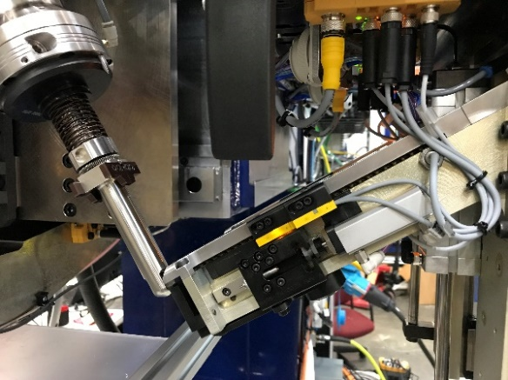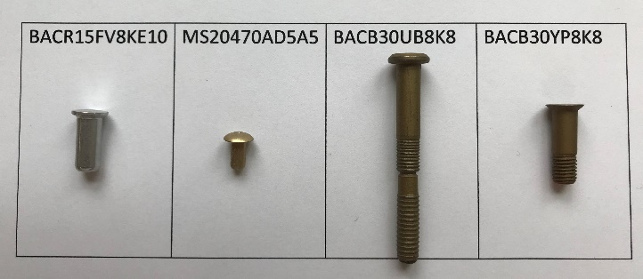

Unique and Flexible Hopper Feed System feeds a wide variety of fasteners

FLEXRIVETER C-Frame Series Rivet Machine

Standard Features

- C-Frame 43.00 Inch Throat Depth
- Cycle Time 5 Seconds Clamp to Unclamp
- Work Height 56 Inches
- Drill spindle Fischer SD60124 10Nm continuous HSK40 pneumatic drawbar
- Upper and lower driver SKF CASM100 Roller Screw Actuator
- Capable of installing universal head, flat head, Briles rivets along with hi-lok, lockbolt and pintail bolts
- Approx. foot print 31” W X 120”H X 120” L
- Approx. Weight 9,500 lbs
- Two Position Head (Drill/Countersink, and Rivet)
- Drill Lubrication System
- Drill spindle water chiller
- Capable of Drilling Aluminum, Steel, and Titanium Alloys
- Countersink depth selection in 0.0005 inch increments
- Variable Drill Feed Adjustable from 0-220 IPM
- Adjustable Drill Speed from 0 to 18000 RPM
- Adjustable (software) dwell delay of 0-500 milliseconds
- Laser Spot Locator
- Upset Force of 16,000 lbf
- Adjustable Clamp Force from 00 to 900 Pounds
- Maximum Stack Thickness 1.8 Inches depending on fastener type
- Deep Drop Daylight Opening Approx. 5 Inches (125mm)
- Quick Change Lower Tooling Mount 16mm bolt attachment
- Manual Tool Rotation of 360 degrees
- Lower Tool Force Air Chip Blowers
- Upset Force Servo Controlled
- Upper Clamp stroke 10 mm
- Up to 900 lb Clamp force
- Tipped Rivet Detection Using Patented Air Gap Sensor
- Siemens Programmable Logic Controller
- Ethernet Communication for Remote Troubleshooting
- Machine Cycle Timer
- Machine Cycle Counter
- Digital RPM Display
- Set Up, Tool Change, and Run Modes
- Soft-touch Operators Station Mounted on a Multi-Link Moveable Arm
- Operating Power 400VAC, 3ph, 60amp
- Tandem Foot Switch Controls With Emergency Stop Button
- Compress Air: 85-100 psi, 25 to 50 CFM
- Pneumatic Master Air Shut Off, Air Filter and Dry Air Regulator Unit
- 4 bin-hopper feed units
- Missing rivet detection

Optional
- Three Position Head (Drill/Countersink, Sealant, and Rivet)
- Sealant Insertion Station
- Pneumatic Control Sealant Dispenser “Semco”
- Quick Change Sealant Tips “Semco”
- Alternate Probe Station with Options Selected
- 8 Bin-Hopper Feed System
- High Force Clamp Nose (1600lb)
- Rivet Clear System
- Camera system (one each upper and lower camera with monitors)
- Safety Light Curtains
- Lower Ram Grip Sensing via Encoder, Displayed in Grip Length Increments/Inches
- Broken Drill Detector
- Four Position Head (Drill/Countersink, Sealant, Probe, Rivet) Or Dual Drill Spindles with Shave Capability
- White Light Rivet Spot Locator.
- Adjustable Forced Air Chip Blowers
- Work light High Intensity Halogen Lamp
- Probe Station for Locating Pre-Drilled Holes
- Vortex Drill Chiller with Pulse Timer
- Rotatable Pressure Foot Bushing.
- C-Frame Up to 96” inch

Cooperative Robot Option
- C-frame comes equiped with cooperative KR10R900 coupon positioner robot which renders it a CNC machine. Can automatically rivet a small door frame.
- Larger robots such as KR350 and KR1000 Titan are available for heavy parts and fixturing
- 